Activity No. 13
Working with Files and Directories in Linux
Course Code: CPE 201A | Program: BSCPE
Course Title: COMPUTER SYSTEM ADMINISTRATION AND TROUBLESHOOTING | Date Performed: 10/22/2026
Section: CPE11S4 | Date Submitted: 10/22/2026
Name: Prince Adrian M. Mangana | Instructor: Lusung, Noel Jason
1. Objective/s:
This activity aims to navigate and manage files and directories using command line interface.
2. Intended Learning Outcome/s:
The students should be able to:
2.1 Demonstrate how to navigate home and system directories
2.2 Demonstrate how to how to list files and directories.b
2.3 Demonstrate how to use globbing to manipulate files and directories.
2.4 Demonstrate how to create, move and delete files and directories.
3. Discussion:
Files and Directories
The Linux filesystem is similar to other operating system’s filesystems in that it contains files and directories. Files contain data such as human-readable text, executable programs, or binary data that is used by the computer.
Directories are used to create organization within the filesystem. Directories can contain files and other directories.
Directory Structure
On a Windows system, the top level of the directory structure is called My Computer. The Linux directory structure, called a filesystem, also has a top level called the root directory (symbolized by the slash /character).

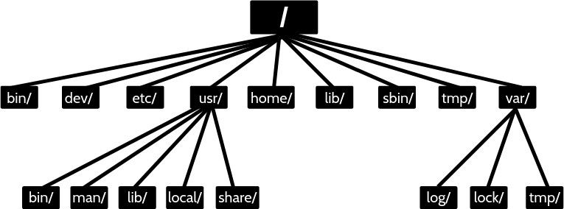

Home Directory
On most Linux distributions there is a directory called home under the root /directory. Under this /home directory there is a directory for each user on the system. When a user opens a shell, they should automatically be placed in their home directory. The user has the full control to create and delete additional files and directories in their home directory. Most other directories in a Linux filesystem are protected with file permissions. The home directory has a special symbol used to represent it, the tilde ~ character.
The directory name is the same as the name of the user. So, a user named sysadmin would have a home directory called /home/sysadmin:
File and Directory Names
File and directory names in Linux can contain lower case and upper case letters, numbers, spaces and special characters. However, since many special characters have a special meaning in the Linux shell, it is good practice to not use spaces or special characters when naming files or directories. Spaces, for example, need the escape character \ to be entered correctly
Paths
A path is a list of directories separated by the / character. There are two types of paths: absolute and relative. For example, /home/sysadmin is a path to the home directory
- Absolute Paths
Absolute paths allow the user to specify the exact location of a directory. Absolute paths always starts at the root directory, and therefore it always begins with the / character.
- Relative Paths
A relative path gives directions to a file relative to the current location in the filesystem. The user must currently be in a directory that contains objects in the path. Relative paths start with the name of a directory.
Special Relative Paths
The single period . character always represents the current directory.
Two period .. characters always represents one directory higher relative to the current directory, sometimes referred to as the parent directory.
4. Resources:
Personal Computer with installed Virtual Box
Ubuntu Server or Desktop virtual machine
5. Procedure:
- Login using your username and password.
- Use terminal emulator application (if you are using desktop version)
- Execute the following commands to navigate files and directories. Copy a screenshot as output after you execute the given command. Create a brief explanation of the command.
Command | Screenshot | Explanation
1. pwd | 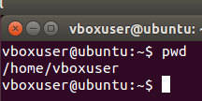 | I used this command to check which directory I was in.
2. cd / | 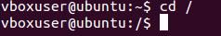 | I used this command to go to the root directory.
3. pwd | 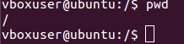 | I checked my current directory again.
4. cd | 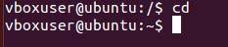 | I went back to my home directory.
5. pwd | 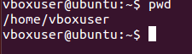 | I checked my current location.
6. cd /home | 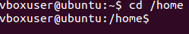 | I went to the directory where user folders are stored.
7. pwd | 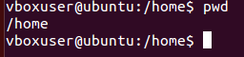 | I checked if I was in the correct directory.
8. cd ~ | 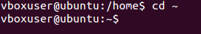 | I used this command to return to my home directory.
9. pwd | 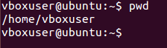 | checked the directory I was currently using.
10. echo ~  ~sysadmin ~root  ~mail ~nobody where sysadmin is your username | 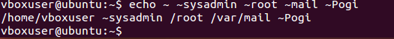 | displayed the home directory paths represented by these symbols.
11. cd ~root | 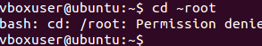 | I tried to go to the root user's home directory.
12. cd /usr/bin | 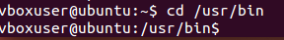 | I went to the directory where many Linux commands are stored.
13. pwd | 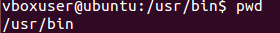 | I checked the full path of my current directory.
14. cd /usr | 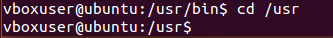 | I moved to the /usr directory.
15. type ls | 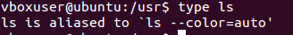 | I checked how the terminal recognizes the ls command.
16. pwd | 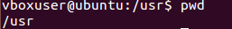 | I checked my current directory.
17. cd /usr/share/doc |  | I went to the directory that contains program documentation.
18. pwd | 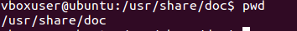 | I checked my current location.
19. cd bash | 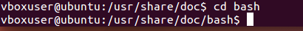 | I tried to open a directory named bash.
20. pwd |  | I checked which directory I was in.
21. cd .. | 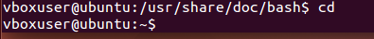 | I moved one level up to the parent directory.
22. pwd | 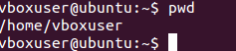 | I checked my directory after moving up.
23. cd ../dict | 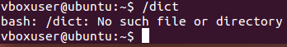 | I tried to go to the dict directory inside the parent directory.
24. pwd | 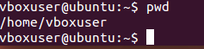 | I checked my current directory
25. cd | 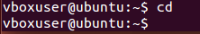 | I returned to my home directory.
26. ls | 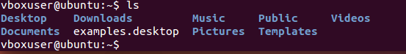 | I listed the files and folders in my current directory.
27. ls -a | 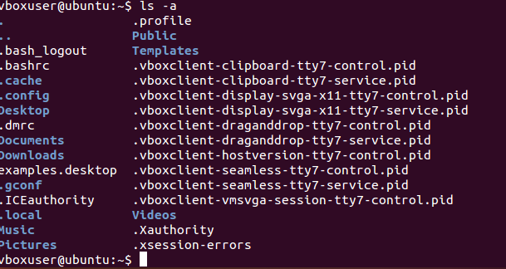 | I listed all files, including hidden files.
28. ls -l /etc/hosts | 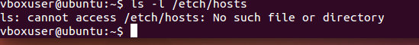 | I viewed the details of the /etc/hosts file.
29. ls -R /etc/udev | 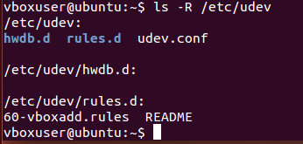 | I listed the files and folders inside /etc/udev, including subfolders.
30. ls -d /etc/s* | 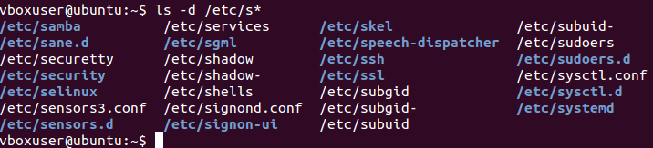 | I displayed entries in /etc that start with the letter s.
31. ls -d /etc/???? | 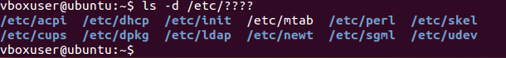 | I displayed entries in /etc with names that have four characters.
32. ls –d /etc/[abcd]* | 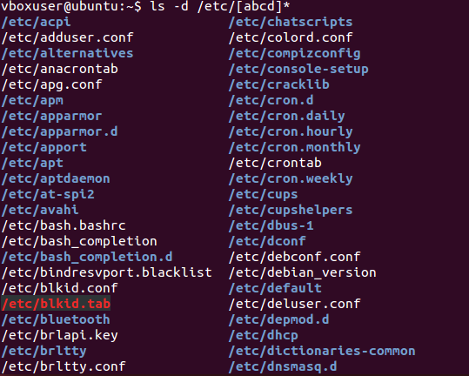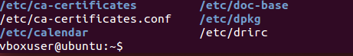 | I displayed entries in /etc that start with a, b, c, or d.

- Execute the following commands to manage files and directories. Copy a screenshot as output after you execute the given command. Create a brief explanation of the command.

Command | Screenshot | Explanation
1. echo * |  | I displayed the names that match any characters in the current directory.
2. echo D* | 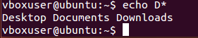 | I displayed names that start with D.
3. echo P* | 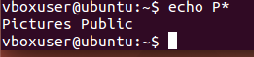 | I displayed names that start with P.
4. echo *s | 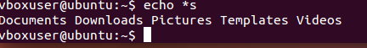 | I displayed names that end with s.
5. echo D*n*s | 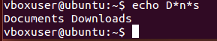 | I searched for names that start with D, have n later, and end with s.
6. echo ?????? | 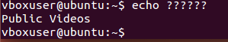 | I displayed names that have exactly six characters.
7. echo D???????? | 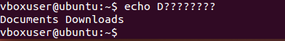 | I displayed names that start with D and have nine characters in total.
8. echo ?????*s | 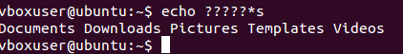 | I displayed names with at least six characters that end with s.
9. echo [DP]* | 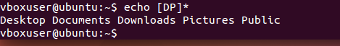 | I displayed names that start with either D or P.
10. echo [!DP]* | 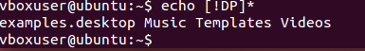 | I displayed names that do not start with D or P.
11. echo [D-P]* |  | I displayed names that start with a letter from D to P.
12. echo [!D-P]* | 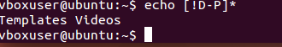 | I displayed names that do not start with a letter from D to P.
13. ls | 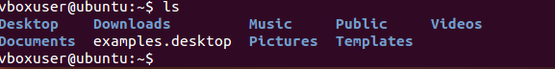 | I listed the files and folders in the current directory.
14. cp /etc/hosts hosts | 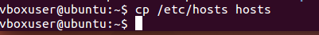 | I copied /etc/hosts and saved the copy as hosts.
15. ls | 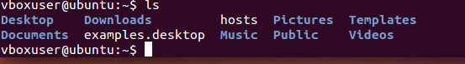 | I checked if the copied file appeared in the directory.
16. rm hosts | 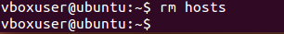 | I deleted the file named hosts.
17. ls | 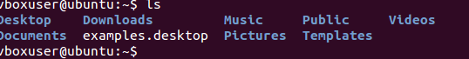 | I checked the directory after deleting the file.
18. cp –v /etc/hosts hosts | 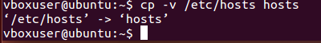 | I copied /etc/hosts to hosts and displayed the copy operation.
19. ls | 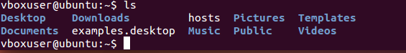 | I checked the files and folders in the current directory.
20. rm hosts | 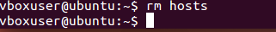 | I removed the file named hosts.
21. ls | 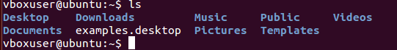 | I checked the directory contents again.
22. cp –v /etc/hosts . | 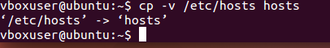 | I copied /etc/hosts into the current directory and displayed the operation.
23. ls | 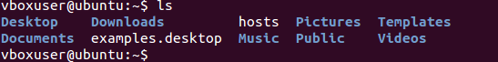 | I checked whether the copied file was there.
24. rm hosts | 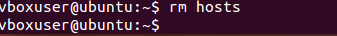 | I deleted the copied hosts file.
25. ls | 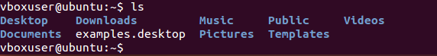 | I checked the directory after removing the file.
26. cd /etc | 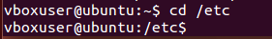 | I changed to the /etc directory.
27. ls -l hosts | 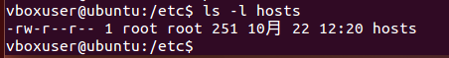 | I viewed the details of the hosts file.
28. cp –p hosts/home/sysadmin |  | I copied hosts to /home/sysadmin while trying to preserve its file details.
29. cd | 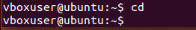 | I returned to my home directory.
30. ls –l hosts |  | I checked the details of hosts in the current directory.
31. rm hosts  32. cp -p /etc/hosts ~  33. cp hosts newname  34. ls –l hosts newname  35. rm hosts newname | 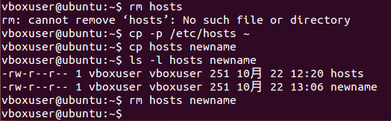 | 31.I removed the file named hosts.  32.I copied /etc/hosts to my home directory while preserving its file details.  33. I made another copy of hosts and named it newname.  34. checked the details of both files.  35. I deleted both hosts and newname.
36. mkdir Myetc  37. cp –R /etc/udev Myetc  38. ls –l Myetc  39. ls –lR Myetc | 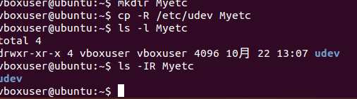 | 36.I created a new directory named Myetc.  37. I copied the udev directory and its contents into Myetc.  38.I listed the contents of Myetc with details.  39. I listed Myetc and its subfolders with details.
40. ls  41. rm -r Myetc  42. ls | 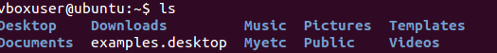 | 40. I checked the files and folders in the current directory.  41. I deleted Myetc together with its contents.  42. I checked the directory after deleting Myetc.
43. touch premove  44. ls  45. mv premove postmove  46. ls  47. rm postmove | 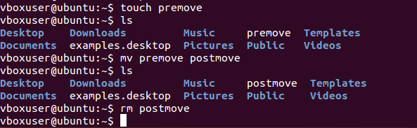 | 43. I created an empty file named premove.  44. I checked if the file appeared in the directory.  45. I renamed premove to postmove.  46. I checked if the file name had changed.  47. I deleted the file named postmove.

6. Supplementary Activity:
Copy screen shot(s) of the following tasks:
- Create a directory CPE231 in the Documents directory. 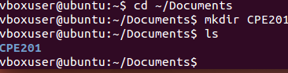
2. Create a directory <lastname> and <firstname> under CPE231 directory.
3. Create two text files: (1) A.txt and (2) B.txt in the <lastname> directory.
4. Copy the content of <lastname> directory to <firstname> directory.
5. Delete the content of <lastname> directory.
6. Create a directory CPE231_backup in the Documents directory.
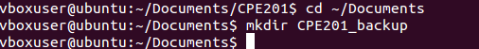
7. Copy the content of CPE231 to CPE231_backup directory.
8. Remove the CPE231 directory. 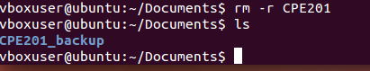

7. Conclusion:
In this activity, I learned how to use different Linux commands to manage files and directories. I was able to practice navigating folders, viewing files, copying and moving files, and creating and deleting directories. This activity helped me become more familiar with using the terminal and understand how these commands can make file management easier.

8. Assessment (Rubric for Laboratory Performance):

